L1 – Raspberry Pi

1. Installing Raspberry Pi OS
To install the Raspberry Pi OS onto the microSD card, download the Raspberry Pi Imager utility from the official Raspberry Pi website.
- Run the Raspberry Pi Imager.
- Click "Choose Device" and select your Raspberry Pi model.
- Click "Choose OS" and select "Raspberry Pi OS (64-bit)".
- Click "Choose Storage" and select your microSD card.
- Before writing, press Ctrl+Shift+X to open the Advanced Options menu, or click the gear icon, to pre-configure the system.

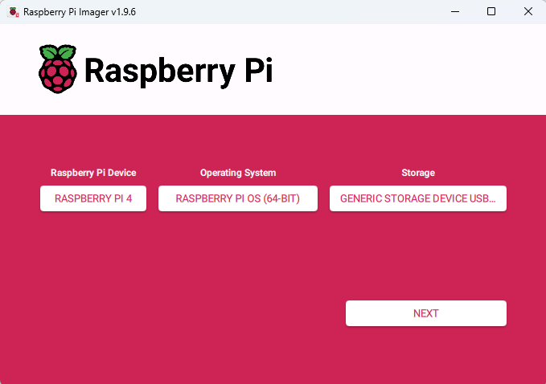

In the Advanced Options:
- Under the General tab, set a hostname (your IAM code), a username and password, and configure Wi-Fi if needed.
- Under the Services tab, enable SSH.
- Under the Options tab, set your locale settings (keyboard layout, timezone).

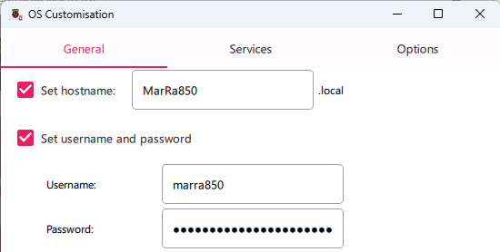
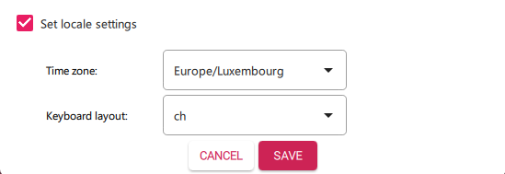
- Click "Save" and then "Write" to begin burning the OS to the microSD card.

2. Initial Configuration of the OS
After the Pi has booted up for the first time:
- Activate Interfaces: Click on the Raspberry Pi logo in the top-left corner, go to Preferences > Control Centre. Navigate to the Interfaces tab and enable SSH, VNC, and I2C. Click "OK".

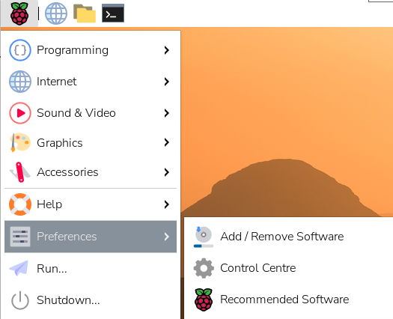
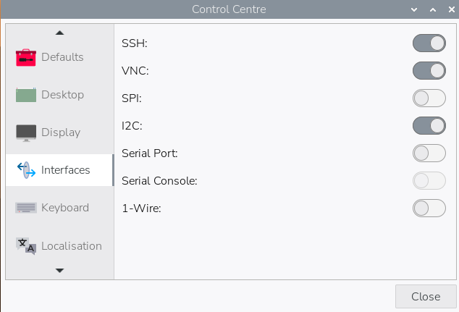

- Set Screen Orientation: Go to Control Centre > Screens. Left-click on Screens, select "Orientation", and choose the correct landscape option (e.g., "Left" or "Right").
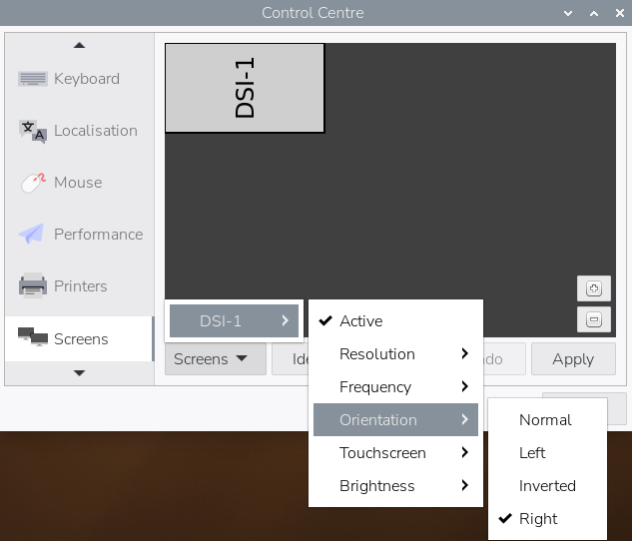

- Connect to Network: Click the network icon in the top-right corner and connect to your Ethernet network or configure Wi-Fi.
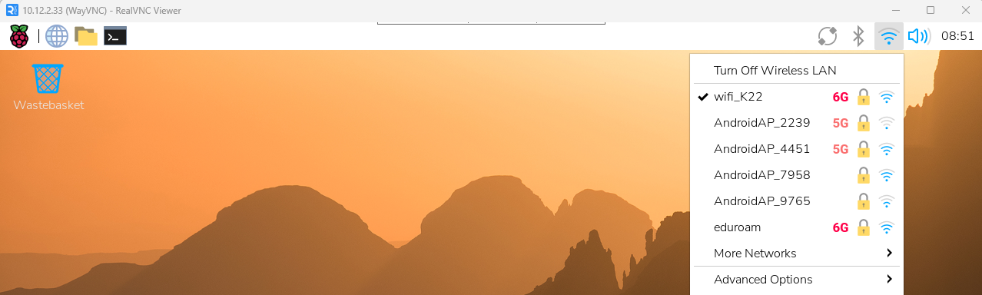

3. Creating Folders and Copying Supplied Files
- Create Required Folders: Open a terminal and run the following command to create the necessary directories:
sudo mkdir /opt/station && sudo mkdir /var/station
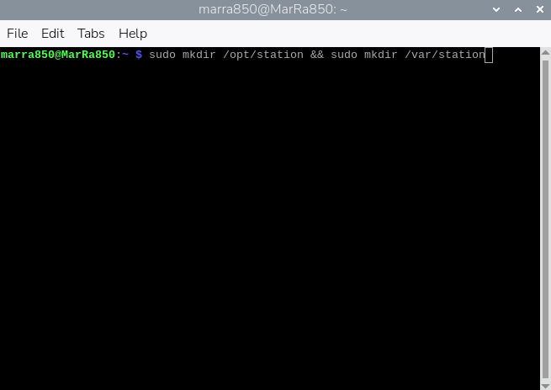

- Transfer Files: On a Windows machine, use a tool like WinSCP to connect to your Raspberry Pi via SSH. Transfer the supplied "Ressourcen" folder to the Pi's home directory.
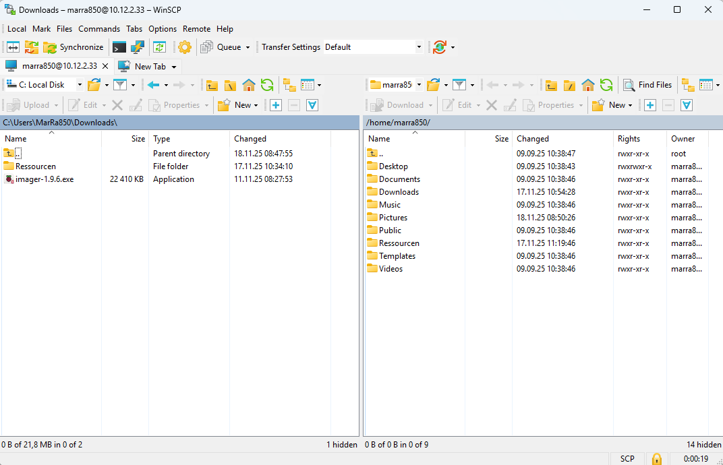

- Copy Files to Correct Locations: Back in the terminal on the Pi, run these commands to copy the files to their final destinations:
sudo cp -r Firmware\ und\ Scripts/ /opt/station/
sudo cp index.php /var/www/html/
sudo mkdir -p /opt/station/www
sudo cp index.php /opt/station/www/
- Adjust Configuration File: Navigate to the firmware files and open the configuration file for editing. The specific command will depend on the file type (e.g., nano /opt/station/Firmware\ und\ Scripts/config.json). Under the I2C section, change the order of the components as specified in your work order document.
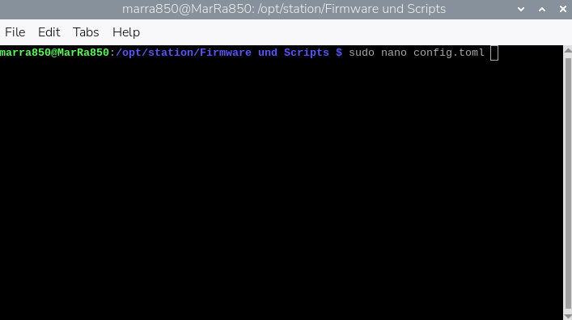
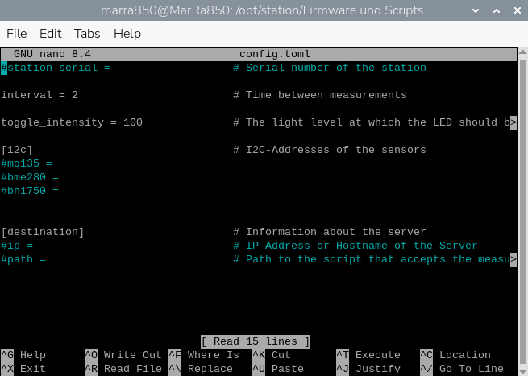

4. Installing Docker
- Download Install Script: In the terminal, use wget to download the Docker installation script:
wget https://get.docker.com -O get-docker.com
- Run the Script: Execute the script with bash to install Docker:
sudo bash get-docker.com
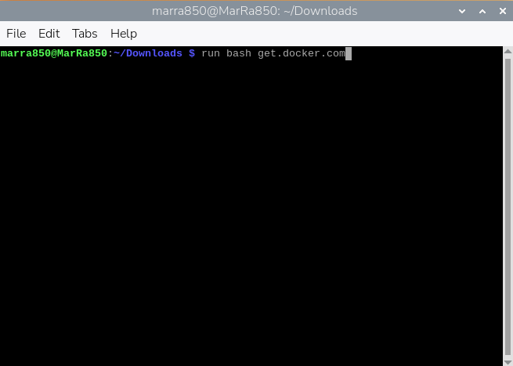
- Create and Run PHP Docker Container: Once installed, run the following command to create a Docker container that will host the website. This command maps the container's port 80 to the Pi's port 8080 and mounts the necessary directories.
docker run -d --name php -p 8080:80 -v /tmp/station:/tmp/station -v /opt/station/www:/var/www/html php:8.4-apache
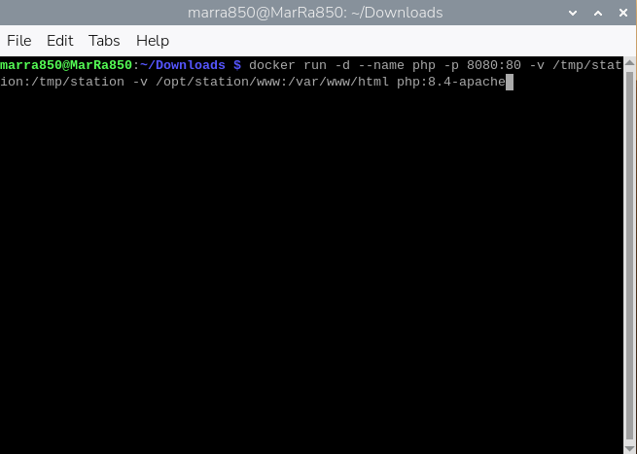

- Configuring the Autostart
To ensure all required services start automatically on boot, we use the LabWC autostart file.
- Create and edit the autostart file:
mkdir -p ~/.config/labwc
nano ~/.config/labwc/autostart
- Add the following lines to the autostart file. This script will:
- Create a temporary directory for sensor data.
- Start the Python3 firmware script in the background to read sensors.
- Ensure the Docker container is running.
- Launch the Firefox browser in full-screen kiosk mode to display the website.
#!/bin/sh
# Create station folder
mkdir -p /tmp/station

# Start the sensor firmware script in the background
python3 /opt/station/Firmware\ und\ Scripts/firmware.py &

# Start the Docker container (if not already running)
docker start php

# Wait a moment for services to start
sleep 10

# Start the browser in kiosk mode
firefox --kiosk http://localhost:8080 &
- Save the file and exit the editor. Then, make the script executable:
chmod +x ~/.config/labwc/autostart
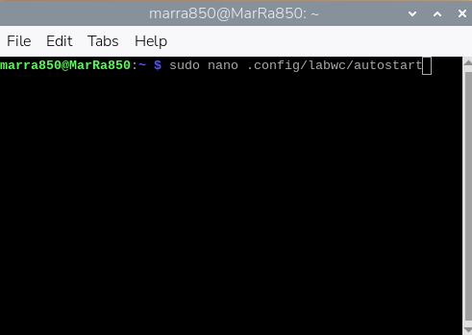
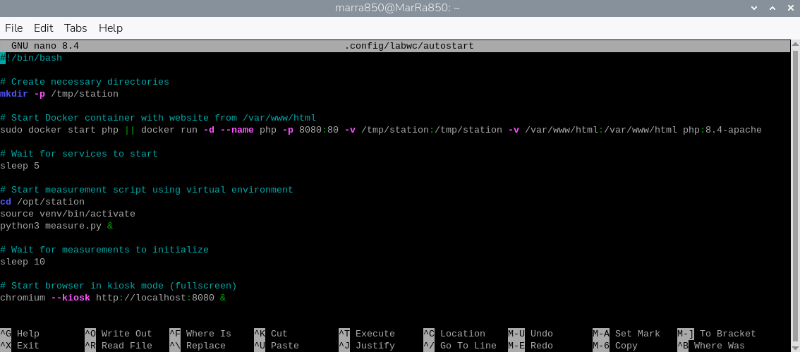
After a reboot, the Raspberry Pi should automatically start reading sensor data, host the website in a Docker container, and display it in kiosk mode.

